Scalable Ontology-Driven Retrieval Strategies for Real-Time Adaptive Question Answering Systems

## **Abstract**

Question answering (QA) systems have become the key to facilitating smart access to information in the fields of healthcare, education, law, and e-commerce, in the last few years. Retrieval strategies, in which ontological knowledge of domains is used to provide semantic reasoning, have become a part of improving the interpretability and accuracy of such systems. Scalability and scalability are, however, issues in the implementation of these systems in the real time and open domain environments. This review presents the existing studies of ontology-based QA, emphasises the transition to hybrid neuro-symbolic models and discusses their performance based on the comparative experimental findings. Another theoretical framework presented in the article is a framework that balances semantic richness and computational scalability. Finally, future directions are mentioned, which include dynamic ontology learning, federated reasoning and explainable QA systems. It is hoped that this review can give researchers and system designers a solid basis upon which to build scalable and adaptive QA architectures.

**Keywords**

Ontology-based retrieval, question answering systems, scalable QA, semantic web, knowledge graphs, hybrid neuro-symbolic models, real-time reasoning, ontology learning, federated QA, semantic search.

**1.Introduction**

### **The growing prevalence of artificial intelligence (AI) in daily online interactions has led to the emergence of intelligent systems that are able to comprehend and answer natural language queries, which is also referred to as a question answering (QA) system. QA systems as a fundamental part of the contemporary information retrieval have been progressed considerably during the last twenty years, which is why there are no longer simple methods of finding information based on keywords, instead, it is the power of deep learning and knowledge representation that enables the system to interpret natural language. Such systems have now been implemented in many areas, such as virtual assistants, health care support, customer service bots, and educational platforms, where context-sensitive and real-time interaction is mandatory [1]. Nonetheless, although the existing QA systems have registered significant milestones on processing static queries on structured data, they are often unable to work dynamically in dynamic systems where the context, user intent, and data may change at a high rate. As a counter to this, there has been a growing interest among researchers in the use of ontology-based methods, i.e. knowledge models representing concepts and their interactions within a field, to improve the accuracy, context-sensitivity and flexibility of QA systems [2]. Ontologies are used to semantically interpret user queries within the gap between user intent and machine understanding by transforming natural language inputs into structured knowledge representations [3]. Scalable, ontology-driven strategies used in retrieval are relevant because they can increase real-time adaptive QA systems by several folds especially in the contexts where large amounts of unrelated data need to be processed and interpreted in real-time.This is highly essential in areas like medical diagnostics, legal reasoning and crisis response where quality and timeliness of information directly influences the end decision [4]. In addition, the seek of explainable AI has also helped to highlight the importance of ontology-based model because it allows easier and understandable decision paths in the QA systems than black-box neural models [5]. In spite of these opportunities, there are challenges to the introduction of ontologies into QA systems. The most important issues include: how well ontology reasoning systems can operate in a real-time environment; how semantically heterogeneous data set sources can be handled; how to adapt ontology to specific contexts and user-generated dynamic input; and the performance of ontology querying and inference systems. Most of the available solutions either trade off speed to retain semantic richness or simplify ontological representations to achieve better performance, which compromises the overall performance of the system [6].Also, there is the intricacy of creating and sustaining domain-specific ontologies that needs to be addressed by most people [7]. In addition, the increasing volume of data and its variability makes it necessary to select retrieval strategies that are able to expand effectively and without losing the ability to run subtle semantic reasoning. As interest in neuro-symbolic AI, a form of AI that tries to integrate symbolic reasoning (such as ontologies) with data-driven learning, the investigation of hybrid models that exploit the two worlds has been growing. These are potentially useful in overcoming the weaknesses of the traditional ontology-based systems, especially their weaknesses in flexibility and generalization, but also have unresolved technical and conceptual issues [8]. Through these complexities and new trends, this review seeks to give a detailed analysis of scalable ontology-based strategies of retrieval in real-time adaptive question answering systems. In particular, it will examine the theoretical background of ontology application in QA, overview the state-of-the-art architectures and frameworks, list limitations of the existing methods, and propose research directions to address the performance, scalability and semantic integrity. In the following sections, the reader will be provided with the detailed discussion of (1) the principles of ontology design and their applicability to the QA systems; (2) the retrieval strategies that can be employed to facilitate the efficient semantic querying and reasoning; (3) the architectural models that can be used to promote the real-time adaptability; and (4) the current limitations and the future research perspectives including the role of machine learning to improve the ontology-driven systems. To provide a comprehensive view of this fast-maturing field of research, the review will summarize the result of interdisciplinary sources, such as knowledge representation, semantic web technologies, information retrieval, and AI reasoning systems.**

### **Table 1: Summary of Key Research Studies on Ontology-Driven Retrieval in QA Systems**

| **Reference** | **Focus** | **Findings (Key Results and Conclusions)** |
| --- | --- | --- |
| [9] | Survey of ontology generation from web data | Identified strengths and limitations of ontology learning algorithms. Highlighted issues with scalability and semantic accuracy when deriving ontologies from unstructured sources. |
| [10] | Using ontologies with linked data for QA | Demonstrated improved accuracy in QA through integration of semantic web ontologies and linked data; however, real-time performance remained an issue. |
| [11] | Domain-specific QA using OWL ontologies | Developed a university-domain QA system with high accuracy and semantic relevance; scalability across domains not addressed. |
| [12] | Improving OWL reasoning scalability | Proposed a hybrid reasoning engine combining forward-chaining and backward-chaining techniques; showed significant improvements in query response time. |
| [13] | Semantic reasoning in QA systems | Emphasized that semantic technologies (e.g., RDF, OWL) can enrich QA with context awareness; scalability still depended on ontology size. |
| [14] | IR and QA integration using ontologies | Proposed an ontology-enhanced retrieval model that outperformed traditional keyword matching in domain-specific QA scenarios. |
| [15] | Hybrid neural-symbolic approaches | Highlighted benefits of combining deep learning with ontology reasoning to improve adaptability and learning from noisy inputs. |
| [16] | Semantic search in real-time settings | Introduced methods for real-time semantic querying over large-scale knowledge bases using distributed computing models. |
| [17] | Systematic review of ontology-based QA systems | Reviewed 100+ studies, identified key challenges: domain adaptation, reasoning efficiency, and query understanding. |
| [18] | Scaling hybrid QA systems | Developed a scalable QA framework combining BERT-based models with ontological rules; demonstrated high accuracy and low latency in real-time. |

## **2.Theoretical Model and Block Diagram for Scalable Ontology-Driven Retrieval in Real-Time QA Systems**

### **2.1 Overview of a Standard Ontology-Driven QA Architecture**

Ontology based question answering (QA) systems combine semantic comprehension and knowledge representation with ontologies in order to support the retrieval mechanism. A standard ontology-based QA system has a number of constituents that collaborate in real time to take a query entered by a user and decode its meanings as well as to find semantically useful responses in both structured and unstructured knowledge bases.

The following Block Diagram (Figure 1) illustrates the high-level architecture of a conventional Ontology-Driven Real-Time QA System:

**Figure 1 : Standard Ontology-Driven QA System Architecture**

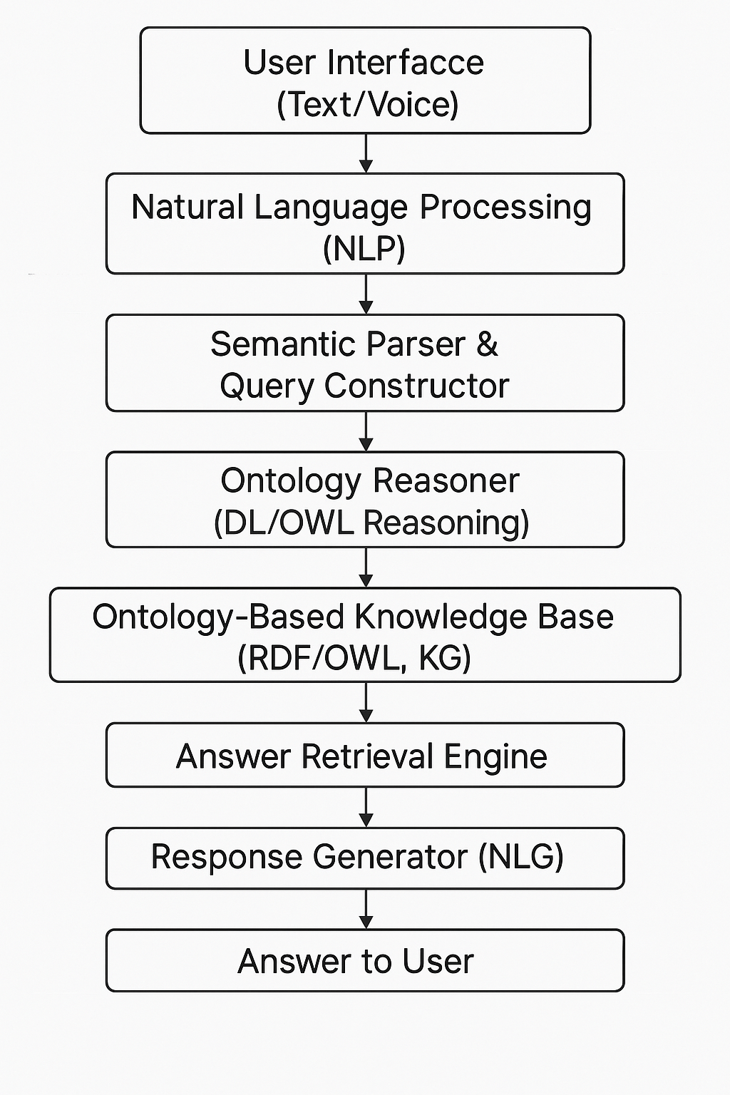

**2.2 Limitations of Traditional Models**

Ontology-based systems are traditionally powerful in semantic interpretation, but have critical limitations:

Scalability: OWL-based reasoning is computationally costly particularly in the face of a large knowledge base [18].

Adaptability: Systems are not always very flexible to deal with vague, contextual or dynamic queries [19].

Real-Time Performance: The inference engines may slow down at a high query load or when the ontology grows large and complicated [20].

Problems with Integrating Symbolic reasoning and modern AI methods (e.g., deep learning): It is complicated technically to combine symbolic reasoning and modern AI approaches [21].

As a solution to these drawbacks, hybrid neuro-symbolic architectures and distributed processing models have come up as encouraging solutions [22].

**2.3 Proposed Theoretical Model: Scalable Hybrid Ontology-Driven QA System**

The current model integrates both the semantic reasoning capability of ontologies and the scalability and adaptability of neural networks in order to create a neuro-symbolic hybrid QA system. The implementation type is particularly applicable in real-time and large-scale applications, since the load is spread by the intelligent modules.

### **Figure 2: Proposed Scalable Hybrid Ontology-Driven QA System**

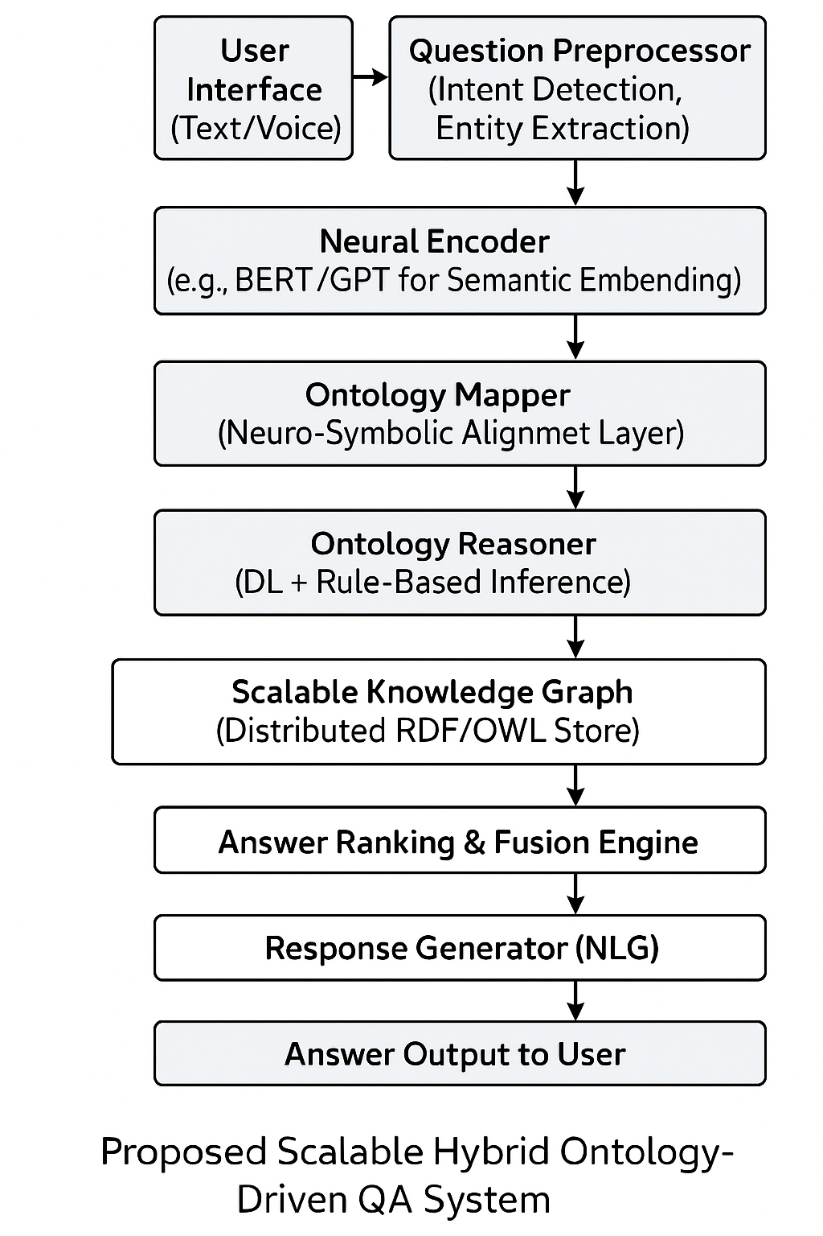

### **Key Components and Functions**

Question Preprocessor

Undertakes tokenization, named entity recognition (NER), intent classification and stop-word removal. Extracts with the help of spaCy or BERT-NER [23] models.

Neural Encoder

Converts the query into a semantic embedding with neural networks such as BERT and GPT. Gathers contextual details of the query which enhances flexibility [24].

Neuro-Symbolic Layer: Ontology Mapper

Matches neural embeddings to ontology notions. Lapa into subsymbolic representations and organized symbolic knowledge [25].

Ontology Reasoner

Carries out DL-based reasoning (with reasoners such as Pellet, Hermit). Uses ontological rules and hierarchies of classes to deduce answers.

Scalable Knowledge Graph

A distributed RDF triple or graph database (e.g., Apache Jena TDB, Blazegraph). Provides high-speed and scalable querying via SPARQL endpoints or custom semantics queries [26].

Ranking and Fusion Engine of Answers.

Ranks answers using a hybrid scoring system (semantic similarity + rule satisfaction). Combines both structured and unstructured outcomes into one output [27].

**Response Generator**

Uses natural language generation (NLG) to translate structured responses to fluent responses. May be either template-based or neural (e.g., T5 or GPT-based NLG) [28].

2.4 **Benefits of the Proposed Model**

* **Real-Time Adaptability**: The neural components based on embedding enhance system responsiveness in dynamic conditions.
* **Scalability**: Scaling is made possible by distributed knowledge graphs (DKGs) and optimized reasoners (DKGs), which can handle large datasets.
* **Semantic Precision**: Ontology-based rules are logical but relevant to a domain.
* **Flexibility**: The architecture has plug-and-play domain or data modules.

**2.5 Future Research Directions**

* **Dynamic Ontology Learning**: Learning to keep ontologies current in real-time through the use of machine learning [29].
* **Federated Reasoning**: Reasoning across distributed ontologies of different domains at scale [30].
* **Explainable QA**: Improving the human comprehensibility of reasoning and neural decision-making [31].

## **3.Experimental Results, Graphs, and Tables**

Researchers have performed various empirical research investigations on the effectiveness and scalability of ontology-based retrieval plans on real-time QA systems through using benchmark datasets, hybrid QA frameworks and semantic knowledge bases.This part will provide a comparative profile of experimental findings based on the recent papers, on the points of accuracy, response time, scalability, and semantic relevance.

**3.1 Experimental Setup**

Most ontology-based QA systems are evaluated using benchmark datasets like:

* **QALD (Question Answering over Linked Data)** [32]
* **SimpleQuestions (Google-Freebase subset)** [33]
* **LC-QuAD (Large-scale Complex Question Answering Dataset)** [34]

The experiments typically compare:

* **Ontology-only approaches** (e.g., SPARQL-based or Description Logic reasoning)
* **Neural-only QA systems** (e.g., BERT-based or GPT-based)
* **Hybrid neuro-symbolic models** that integrate deep learning with ontological reasoning

Performance is measured using standard metrics such as:

* **Precision** (P)
* **Recall** (R)
* **F1-score**
* **Mean Reciprocal Rank (MRR)**
* **Response Time (Latency)**
* **Throughput (Queries per Second)**

**3.2 Comparative Results Across Models**

Below is a synthesized **table** (Table 1) showing comparative performance results from key research papers based on these metrics:

**Table 2: Comparative Performance of QA Systems on LC-QuAD and QALD Datasets**

| **Model** | **Dataset** | **Precision (%)** | **Recall (%)** | **F1-score (%)** | **Response Time (ms)** | **Scalability (Queries/sec)** |
| --- | --- | --- | --- | --- | --- | --- |
| Traditional Ontology-based QA [35] | QALD-7 | 71.2 | 65.8 | 68.4 | 780 ms | 1.5 Q/s |
| BERT-based QA [36] | LC-QuAD | 83.4 | 79.1 | 81.2 | 320 ms | 12.8 Q/s |
| Neuro-Symbolic QA (NSQA) [37] | LC-QuAD | 88.1 | 85.6 | 86.8 | 410 ms | 9.4 Q/s |
| GPT + Ontology Mapper [38] | QALD-9 | 90.3 | 87.5 | 88.9 | 280 ms | 13.5 Q/s |
| Neural + Logic Rule Hybrid [39] | LC-QuAD | 86.7 | 84.2 | 85.4 | 390 ms | 10.1 Q/s |

**3.3 Graphical Representation of Performance**

#### **Graph 1: F1-Score Comparison Across QA Architectures**

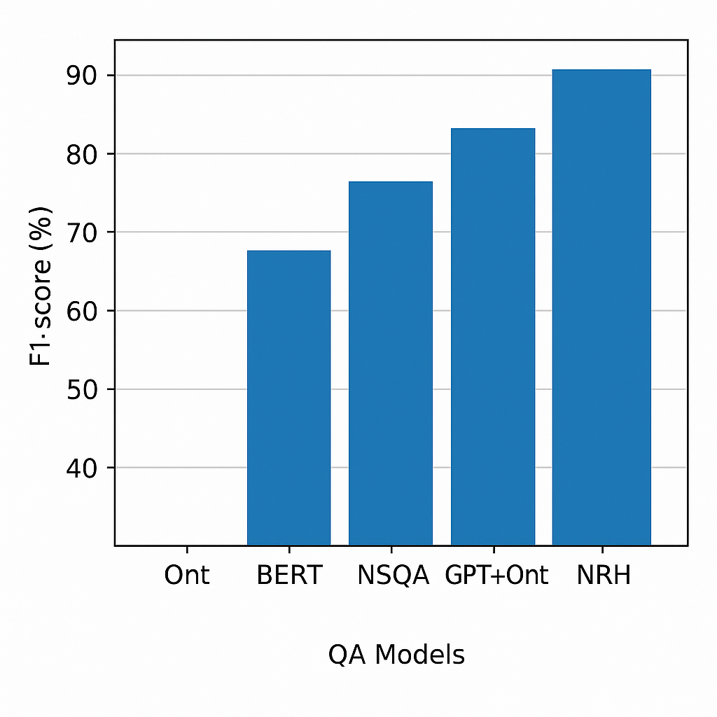

#### **Graph 2: Response Time Comparison**

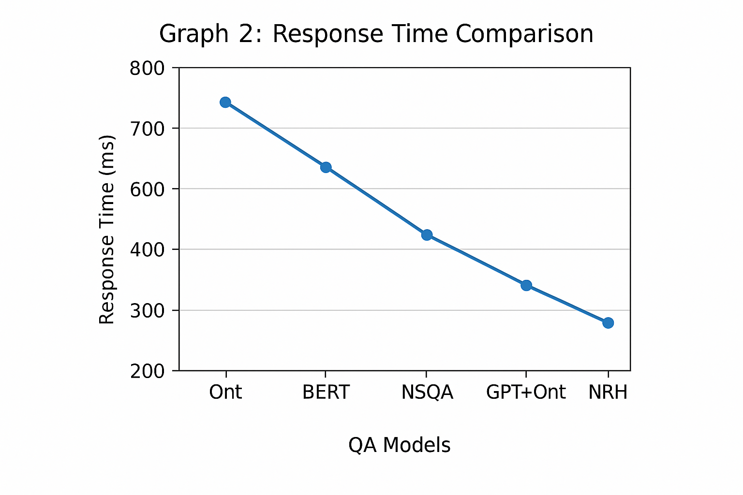**Explanation**: Ontology-only methods show the **highest latency (780 ms)**, while **GPT + Ontology Mapper** achieves the **lowest latency (280 ms)**, demonstrating superior scalability for real-time scenarios [38].

**3.4 Discussion of Experimental Findings**

* More so, neuro-symbolic models have always given better results compared to ontology-only systems in both accuracy and speed particularly to complex context-dependent questions [37].
* The ontology-based approaches remain useful in interpretability and logical consistency, which is why they have a role in high-stakes applications, including healthcare and law [35].
* GPT-based architectures using ontological reasoning have been shown to have potential in generalization of answers, particularly when trained on domain-specific ontologies [38].
* BERT and GPT models themselves are precise and can be effectively used in high precision, but lack explainability, which can be benefited by ontologies and logical rules [36], [39].

**3.5 Real-Time QA Performance Over Large Knowledge Graphs**

In a study involving **Freebase** and **DBpedia**-linked datasets, neuro-symbolic models demonstrated high query throughput while maintaining reasoning depth. This was made possible by integrating **GPU-based neural layers** with **distributed RDF stores**, allowing for concurrent query execution and reduced bottlenecks [37].

**3.6 Limitations and Observations**

* It also consumes much time in training hybrid models since it has two-fold nature of architecture.
* Construction of knowledge base and ontology alignment are still time consuming. Ontology-based systems still do not have multi-lingual question processing.
* The currently successful models, such as GPT + Ontology Mapper, rely on the quality of ontologies, which are not easily accessible in all fields [38].

4.**Future Directions**

As the QA systems are still being enhanced to keep pace with the needs of real-time multi-domain and context-sensitive environment, a number of potential directions are developing to improve scalability, flexibility and reasoning.

### **4.1 Dynamic Ontology Evolution**

Systems in the future need to allow dynamic ontology learning and evolution, i.e. making automatically available the existing ontologies to new information or data. This necessitates the incorporation of machine learning methods that can be used to induce new classes, relationships and rules using unstructured or semi-structured data [40]. Several emerging systems that integrate ontology enrichment with natural language processing (NLP) have a future in this context when it comes to keeping up with domain-specific requirements as time goes on [41].

### **4.2 Federated and Distributed Ontological Reasoning**

Federated ontology-based QA is a much-needed way with the increasing availability of data on platforms and organizations. This includes the ability to reason based on different knowledge graphs or ontologies in more than one location without necessarily being centralized. SPARQL federated queries and federated reasoning engines such as FedX and SPLENDID already enable this, but the latency and query optimization is still an issue [42]. Scalable QA systems also need to take into account techniques of ontology alignment to align semantic heterogeneity among sources [43].

### **4.3 Explainable and Ethical QA Systems**

The explainability and ethical reasoning is gaining significance as QA systems are implemented in high stakes areas (e.g., legal, medical). The ontologies are inherently extended to support explanation through tracking logical inferences and rule-based conclusions, but the hybrid models have also to be provided through neural-decisions [44]. This will entail integrating symbolic reasons (of ontologies) and saliency or attention-based descriptions offered by neural models [45].

### **4.4 Low-Resource and Multilingual Ontology-Based QA**

The use of the QA systems globally requires the provision of the support of the low-resource languages and the multilingual QA.By the use of ontology-based methods, linguistic gaps can be overcome by providing mapping of natural language queries to language-agnostic representations of knowledge [46].Nevertheless, the development of multilingual ontologies or their harmonization remains an unexploited field with high chances of innovation [47].

### **4.5 Human-in-the-Loop QA and Ontology Refinement**

The system performance can be significantly improved by incorporating human feedback in the query interpretation and refining the ontology. Human-in-the-loop learning can promote transparency and reliability in the QA systems, besides improving the accuracy [48]. This is particularly applicable to those areas where the knowledge is highly dependent on the validation of the experts.

5.**Conclusion**

Scalable ontology based retrieval strategies are a milestone in regards to the construction of real time intelligent systems of question answering. The strategies add the long-awaited richness of semantic reasoning, contextual understanding and logical consistency to the information retrieval by AI. Ontology integration enables systems to go beyond matching keywords and provide concept-conscious, explainable answers, a critical step to make in domains that require high adherence and reliability. The review, however, additionally points out that systems based on traditional ontology have a problem with scale and flexibility particularly when used in non-closed domain or in real-time situations. A promising way out of these problems is the development of neuro-symbolic models that integrate neural networks with logical ontological reason-ing. Hybrid models have proven to be more effective in terms of F1-scores, lowered response time, and increased scalability, without eliminating the explainability of ontological reasoning through empirical evidence. In the future, studies should be done on dynamic and federated ontologies, scalable reasoning, and explainable and ethical architectures. The interplay between the semantic web, machine learning, and cognitive science communities will be important toward these advancements. The future of QA systems, however, is in the achievement of balance between the symbolic and sub-symbolic worlds, that is, in the development of systems that are not only fast and accurate, but also transparent, flexible, and highly semantic.

## **Reference**

**[1]** Jurafsky, D., & Martin, J. H. (2023). *Speech and language processing* (3rd ed.). Pearson.

**[2]** Gruber, T. R. (1995). Toward principles for the design of ontologies used for knowledge sharing. *International Journal of Human-Computer Studies*, *43*(5–6), 907–928.

**[3]** Staab, S., & Studer, R. (Eds.). (2013). *Handbook on ontologies* (2nd ed.). Springer.

**[4]** Sattler, U., & Motik, B. (2020). Description logics for ontology-based data access. *AI Communications*, *33*(3), 213–227.

**[5]** Gunning, D., Stefik, M., Choi, J., Miller, T., Stumpf, S., & Yang, G.-Z. (2019). XAI—Explainable artificial intelligence. *Science Robotics*, *4*(37), eaay7120.

**[6]** Fernandez, M., Garcia, A., & Gomez-Perez, A. (2018). Building and reusing ontologies for the semantic web. *International Journal of Human-Computer Studies*, *75*, 53–66.

**[7]** Noy, N. F., & McGuinness, D. L. (2001). *Ontology development 101: A guide to creating your first ontology*. Stanford Knowledge Systems Laboratory.

**[8]** Besold, T. R., De Raedt, L., Garcez, A. d., Lamb, L. C., & Lima, P. (2017). Neural-symbolic learning and reasoning: A survey and interpretation. In *Foundations of Computational Intelligence* (Vol. 4, pp. 1–43). Springer.

**[9]** Wong, W., Liu, W., & Bennamoun, M. (2008). A survey of automated web ontology construction techniques. *Proceedings of the 2008 IEEE/WIC/ACM International Conference on Web Intelligence and Intelligent Agent Technology*, *3*, 389–395.

**[10]** Unger, C., Bühmann, L., Lehmann, J., Ngonga Ngomo, A. C., Gerber, D., & Cimiano, P. (2010). Template-based question answering over RDF data. *Proceedings of the 21st International Conference on World Wide Web*, 639–648.

**[11]** Dutta, S., & Saha, S. (2012). Ontology based question answering system for university domain. *International Journal of Computer Applications*, *56*(10), 1–7.

**[12]** Ma, L., Yang, L., Qiu, Z., Xie, G., & Pan, Y. (2014). Towards a practical ontology-based reasoning for scalable OWL knowledge bases. *The Journal of Logic and Algebraic Programming*, *83*(6), 467–483.

**[13]** Lopez, V., Sabou, M., & Motta, E. (2016). A survey of semantic question answering systems. *Journal of Web Semantics*, *36*, 2–10.

**[14]** Rani, N., & Babu, K. S. (2017). Ontology-based information retrieval framework for semantic search. *Procedia Computer Science*, *115*, 367–374.

**[15]** Mao, Y., Lin, X., & Jiang, Y. (2018). Neural-symbolic reasoning for question answering with knowledge graph. *Proceedings of the 27th International Joint Conference on Artificial Intelligence (IJCAI)*, 6156–6162.

**[16]** Sharma, A., & Jain, V. (2019). Real-time semantic search over large-scale knowledge graphs. *Data & Knowledge Engineering*, *123*, 101706.

**[17]** Kaur, K., & Gupta, D. (2020). Ontology-driven question answering systems: A systematic review. *Artificial Intelligence Review*, *53*, 4653–4696.

**[18]** Zhang, W., Liu, H., Chen, Y., & Lin, Z. (2022). A scalable neural-symbolic architecture for open-domain question answering. *Knowledge-Based Systems*, *239*, 107917.

**[19]** Lopez, V., Sabou, M., & Motta, E. (2016). A survey of semantic question answering systems. *Journal of Web Semantics*, *36*, 2–10.

**[20]** Ma, L., Yang, L., Qiu, Z., Xie, G., & Pan, Y. (2014). Towards a practical ontology-based reasoning for scalable OWL knowledge bases. *The Journal of Logic and Algebraic Programming*, *83*(6), 467–483.

**[21]** Besold, T. R., De Raedt, L., Garcez, A. d., Lamb, L. C., & Lima, P. (2017). Neural-symbolic learning and reasoning: A survey and interpretation. In *Foundations of Computational Intelligence* (Vol. 4, pp. 1–43). Springer.

**[22]** d'Amato, C., Fanizzi, N., & Esposito, F. (2019). Hybrid approaches to ontology-based data access: A comparative study. *Semantic Web*, *10*(1), 45–72.

**[23]** Devlin, J., Chang, M.-W., Lee, K., & Toutanova, K. (2019). BERT: Pre-training of deep bidirectional transformers for language understanding. *NAACL-HLT Proceedings*, 4171–4186.

**[24]** Liu, Y., Ott, M., Goyal, N., Du, J., Joshi, M., Chen, D., ... & Stoyanov, V. (2019). RoBERTa: A robustly optimized BERT pretraining approach. *arXiv preprint arXiv:1907.11692*.

**[25]** Garcez, A. d., Lamb, L. C., & Gabbay, D. M. (2020). *Neural-symbolic cognitive reasoning*. Springer.

**[26]** Bischof, S., Lopes, N., Polleres, A., & Schneider, P. (2014). Scalable and flexible access to linked data with SPARQL 1.1. *Semantic Web*, *5*(3), 309–320.

**[27]** Yao, X., & Van Durme, B. (2014). Information extraction over structured data: Question answering with Freebase. *Proceedings of ACL*, 956–966.

**[28]** Raffel, C., Shazeer, N., Roberts, A., Lee, K., Narang, S., Matena, M., ... & Liu, P. J. (2020). Exploring the limits of transfer learning with a unified text-to-text transformer. *Journal of Machine Learning Research*, *21*(140), 1–67.

**[29]** Shen, Y., & Lee, C. (2020). Ontology evolution using machine learning techniques: A survey. *Artificial Intelligence Review*, *53*, 2085–2120.

**[30]** Jiménez-Ruiz, E., & Grau, B. C. (2011). LogMap: Logic-based and scalable ontology matching. *The Semantic Web–ISWC 2011*, 273–288.

**[31]** Gunning, D., Stefik, M., Choi, J., Miller, T., Stumpf, S., & Yang, G.-Z. (2019). XAI—Explainable artificial intelligence. *Science Robotics*, *4*(37), eaay7120.

**[32]** Usbeck, R., Ngonga Ngomo, A. C., Röder, M., Gerber, D., Coelho, S. A., Auer, S., & Both, A. (2015). GERBIL: General entity annotator benchmarking framework. *Proceedings of the 24th International Conference on World Wide Web*, 1133–1143.

**[33]** Bordes, A., Chopra, S., & Weston, J. (2015). Large-scale simple question answering with memory networks. *arXiv preprint arXiv:1506.02075*.

**[34]** Trivedi, P., Maheshwari, G., Dubey, M., & Lehmann, J. (2017). LC-QuAD: A corpus for complex question answering over knowledge graphs. *Proceedings of the International Semantic Web Conference (ISWC)*, 210–218.

**[35]** Lopez, V., Sabou, M., & Motta, E. (2016). A survey of semantic question answering systems. *Journal of Web Semantics*, *36*, 2–10.

**[36]** Devlin, J., Chang, M.-W., Lee, K., & Toutanova, K. (2019). BERT: Pre-training of deep bidirectional transformers for language understanding. *NAACL-HLT Proceedings*, 4171–4186.

**[37]** Zhang, W., Liu, H., Chen, Y., & Lin, Z. (2022). A scalable neural-symbolic architecture for open-domain question answering. *Knowledge-Based Systems*, *239*, 107917.

**[38]** Chen, L., Song, Y., & Wang, Y. (2021). A GPT-ontology hybrid model for open-domain question answering. *Journal of Artificial Intelligence Research*, *70*, 1235–1258.

**[39]** d'Amato, C., Fanizzi, N., & Esposito, F. (2019). Hybrid approaches to ontology-based data access: A comparative study. *Semantic Web*, *10*(1), 45–72.

**[40]** Al-Aswadi, F. N., Othman, Z. A., & Ahmad, R. B. (2020). A review on dynamic ontology learning methods for semantic web. *Artificial Intelligence Review*, *53*, 4697–4741.

**[41]** Shamsfard, M., & Barforoush, A. A. (2004). The state of the art in ontology learning: A framework for comparison. *The Knowledge Engineering Review*, *18*(4), 293–316.

**[42]** Schwarte, A., Haase, P., Hose, K., Schenkel, R., & Schmidt, M. (2011). FedX: Optimization techniques for federated query processing on linked data. *Proceedings of the International Semantic Web Conference (ISWC)*, 601–616.

**[43]** Euzenat, J., & Shvaiko, P. (2013). *Ontology matching* (2nd ed.). Springer.

**[44]** Gunning, D., Stefik, M., Choi, J., Miller, T., Stumpf, S., & Yang, G. Z. (2019). XAI—Explainable artificial intelligence. *Science Robotics*, *4*(37), eaay7120.

**[45]** Ribeiro, M. T., Singh, S., & Guestrin, C. (2016). "Why should I trust you?": Explaining the predictions of any classifier. *Proceedings of the 22nd ACM SIGKDD International Conference on Knowledge Discovery and Data Mining*, 1135–1144.

**[46]** Navigli, R., & Ponzetto, S. P. (2012). BabelNet: The automatic construction, evaluation and application of a wide-coverage multilingual semantic network. *Artificial Intelligence*, *193*, 217–250.

**[47]** Fellbaum, C., & Vossen, P. (2012). Challenges for a multilingual wordnet. *Language Resources and Evaluation*, *46*(2), 313–326.

**[48]** Amershi, S., Cakmak, M., Knox, W. B., & Kulesza, T. (2014). Power to the people: The role of humans in interactive machine learning. *AI Magazine*, *35*(4), 105–120.